1.4 Length of a Plane Curve

General Idea:
Determine the length of the following curves:
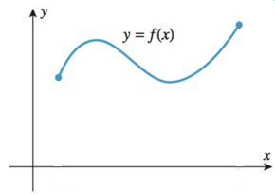
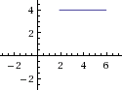

The Specifics:
Suppose is a function with a continuous first derivative on the interval . Also suppose that a curve C is defined by the equation where .

Theorem (The Arc Length Formula): If is continuous on , then the length of the curve where is

Note: If a curve has the equation , where and is continuous on then

Example 1: Find the exact length of the curve determined by between the points and .

- Determine this by integrating with respect to x.

- Determine this arc length by integrating with respect to y.

Example 2: Set up, and evaluate using your calculator, an integral equal to the arc length of the arc of the parabola from to .

Definition: Suppose the curve C is given by where and is continuous on . We define the arc length function for the curve C as the function with domain given by the formula:

Note: The point is often referred to as the starting point, and in some problems we use as the interval rather than .

Note: By the fundamental theorem of calculus we see that . So, the differential of arc length is .

Note: When x is a function of y the arc length differential becomes: .

Note: When a curve C is given by a function with a continuous first derivative we call C a smooth curve. It is important to note that in this section we are working with smooth curves, but the notion of arc length can be generalized to include curves that are given by a continuous function (such a generalization does not even require that the function is differentiable!).

Example 3: Consider the function .
- Find the arc length function (simplify until no integral remains) for this function is taken to be the starting point (Hint: the radical should simplify nicely).

- Use your answer to (a) to find the exact arc length along the curve from to

